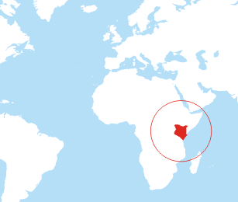

**What do you like about where you live? Where else would you like to live?**

**Compare**

**Our African Adventure Continues…**

**Drought**

**What is a drought? Can you explain why water is so important?**

**What do you think it would be like to live in Kenya? What are the homes like? Can you make a model of a traditional African mud hut?**

**Have you followed a map? What do the symbols on a map mean? Can you find your house or Stokesley on a map?**

**Kenya**

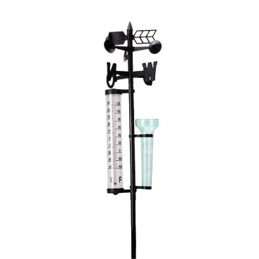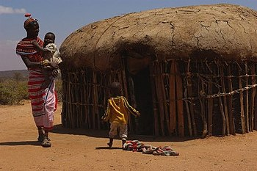

**Can you keep a record of the weather each day? How do you think it would be different in Kenya?**

**Weather**

**Books to Explore:**

Bringing the Rain to the Kapiti Plain by Verna Aardema

A is for Africa by Ifeoma Onyefulu

The Day the rains fell by A Faundez

Furaha Means happy: a book of Swahili words K Wilson-Max

Mama Panya’s Pancakes R Chamberin

**Season**

**Map**

**Do you know what the weather is like in each season? Can you name all 4 seasons?**

**Things you could do:**

Go to the library and borrow a book. Have a look at maps and Atlases.

Explore: <https://www.bbc.co.uk/programmes/p0114nj6>

https://www.bbc.com/bitesize/clips/zgmn34j