

**Travel**

**If you could travel to a different part of the world, where would you go? How would you travel there?**

**Route**

**Can you follow a route on a map?**

**Which words do we use when we give directions?**

**Could you really be blown away?**

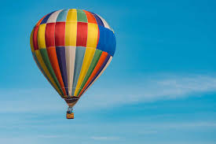

**How is the weather different in different parts of the world?**

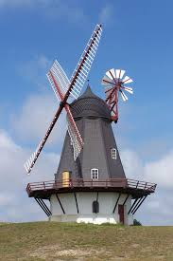

**Weather**

**Journey**

**How many different ways can you think of to make a journey?**

**What is your favourite type of weather? Why?**

**Things you could do:**

**F**ollow a route on a map or draw your own map of a journey you have taken.

Draw or paint a picture of your favourite type of weather

Find out about the weather in different places in the world.

Make a list of all the different ways to travel that you can think of.

Go out on a spring walk, draw a spring picture, make a weather chart of the weather each day.

**Don’t forget to bring your work in to show us .**

**Books to Explore, why not borrow one from the library:**

* Feel the wind, Arthur Dorros
* The windy day, Anna Millbourne
* Flora’s very windy day, Jane Birdsall
* I wonder why the wind blows and other questions about our planet
* Kite day, Will Hillenbrand
* Kate who tamed the wind, Liz Garton Scanlon

**Climate**