Why do farmers use poly tunnels?

**Food miles**

**Where does our food come from?**

How many miles does your food travel?

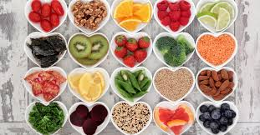

**Organic**

“You are what you eat”

Agree or disagree?

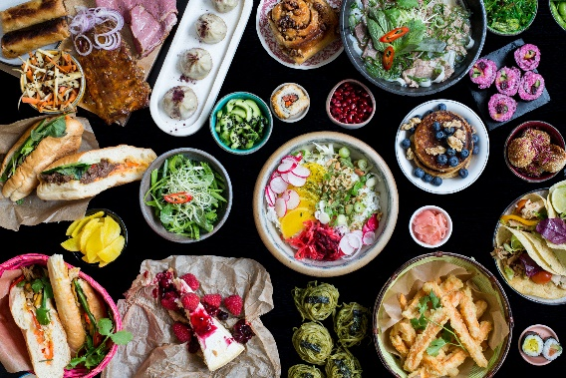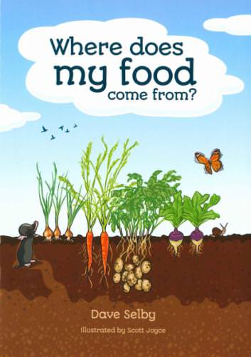

Is breakfast the MOST important meal of the day? Explain

**Balanced Diet**

**Preservatives**

How have cooking processes changed over time?

What’s your family’s special dish?

**Seasonal**

**Things you could do:**

Watch a food programme.

Look at food packaging and make a record of where the products have come from. Which product travelled the furthest?

Try a new food and write a short review about your experience

**Books and Websites to Explore:**

Farm to Fork: http://www.foodafactoflife.org.uk/

100 Things to Know About Food by Sam Baer and Rachel Firth

Nadiya's Bake Me a Story: Fifteen stories and recipes for children by Nadiya Hussain

**Free-range**