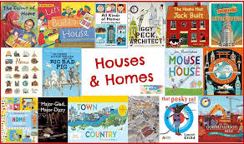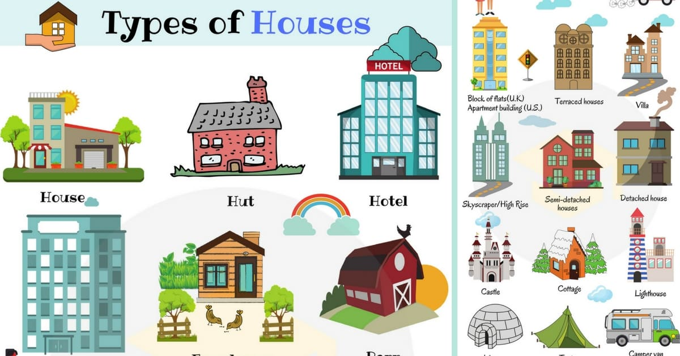

What shapes can you spot when you look at the buildings on your way to school?

D+T STEM Project : Homes

(**S**cience, **T**echnology, **E**ngineering and **M**aths)

Structure

How have homes changed over time. Ask family and friends or why not investigate at the library. If you have time you could visit the museum at Preston Hall or York Castle museum.

Are homes the same all over the world? How are they the same or different? What other materials are used?

What materials is your home made from? Can you find part of your house that is wood, metal, plastic, glass or stone?

Construction

Architect

Material

What do you like about your home? Do you know your address?

**Home Learning:**

* Please help your child to learn their address and if possible, send in a photo of their home. These can be emailed to [l.challenger@stokesleypa.org.uk](mailto:l.challenger@stokesleypa.org.uk)
* Spot shapes and materials in your home and other homes that you see. Try to spot similarities and differences.
* Share a story, read a book, visit the library
* Please could you send in small/medium sized cardboard boxes and other junk modelling materials for us to use in school. Thank you. Why not have a got at home, work together and make a model house, it could be your home, a dream home or a home from the past or a different place in the world. Get creative and have fun, we would love to see what you make.