**Friction**

**Penguin**

**Journey to the North**

**Why is friction important in ice skating?**

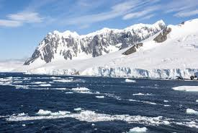

**Find out 5 facts about penguins**

**Compass**

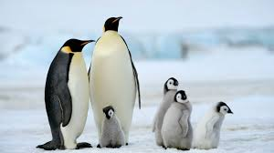

**Below zero**

**How do you use a compass?**

**What would you wear to survive in the poles?**

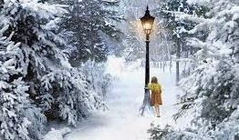

**Northern Hemisphere**

**Which countries are in the Northern Hemisphere?**

**What is happening to the ice caps?**

**Glaciers**

**Books/websites to explore:**

<https://www.bbc.co.uk/bitesize/topics/zyhp34j/articles/zjg46v4>

Frozen Planet e.g. <https://www.youtube.com/watch?v=t12bmlDEV3I>

Books by Jackie Morris e.g. The Ice Bear, The Snow Leopard

My Father is a Polar Bear by Michael Morpurgo

The snow whale by Caroline Pitcher

**Things you could do:**

Go to the library and borrow a book.

Visit Penguins at Lotherton Hall, The Deep or The Sea Life Centre

Watch or read **The Lion, the Witch and the Wardrobe**

Find out about artic animals

Make a snow globe /snow volcano <https://www.growingajeweledrose.com/2013/12/how-to-make-snow-volcano.html>