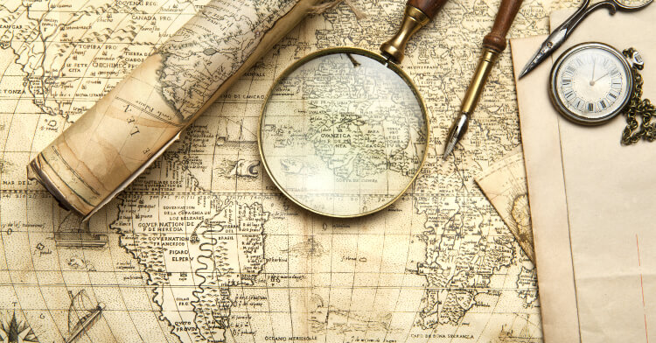

**agriculture**

**What is a cartographer?**

**See the land like the Iron Man.**

**What is a key for on a map?**

**landmark**

**What are compass points?**

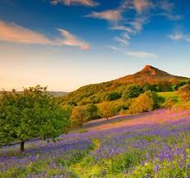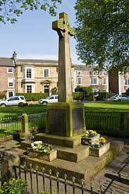

**Things you could do:**

Draw a simple map of one of your favourite places. Be sure to include any special features.

Use a compass to find out the direction that your house faces.

Give verbal instructions to direct a family member to a location close to your home. If you have permission to try them out to see if they work.

**community**

**cartographer**

**How is land used for farming?**

**urban**

**rural**

**What are co-ordinates?**

**How is land used?**