**Can you think of any objects which use/contain magnets?**

**surface**

**Metal Mystery!**

**How many metals can you name?**

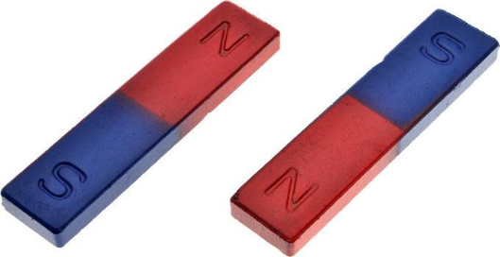

**magnetic**

**What happens to scrap metal?**

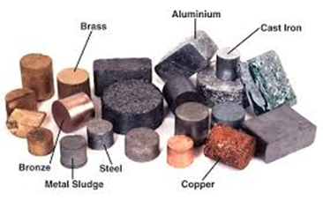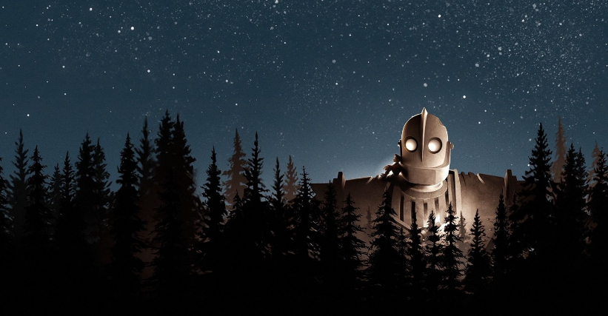

**Is Earth magnetic?**

**friction**

**Things you could do:**

Use a magnet to investigate the force of magnetism.

Find out some fun magnet facts.

Learn to spell the topic words.

**Books/websites to explore:**

[**https://www.ducksters.com/science/magnetism.php**](https://www.ducksters.com/science/magnetism.php)

[**https://www.theschoolrun.com/homework-help/magnets**](https://www.theschoolrun.com/homework-help/magnets)

[**https://www.coolkidfacts.com/magnetism-facts-for-kids/**](https://www.coolkidfacts.com/magnetism-facts-for-kids/)

[**https://kids.britannica.com/kids/article/Magnet-and-Magnetism/353411#**](https://kids.britannica.com/kids/article/Magnet-and-Magnetism/353411)

**iron**

**repel**

**attract**

**What are the properties of metals?**

**What are magnetic poles?**