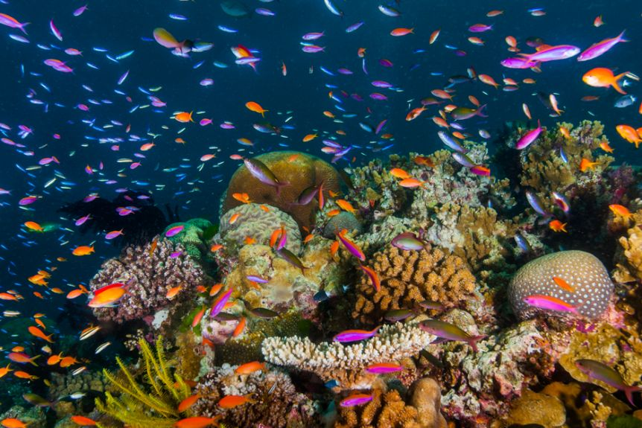

**route**

**Can you follow a route on a map?**

**Which words do we use when we give directions?**

**What happens to different materials when they get wet?**

**Which materials will float?**

**How can we change our world?**

**investigate**

**Coral reef**

**What is a coral reef?**

**Which creatures live there?**

**If you could change the world, what would you change?**

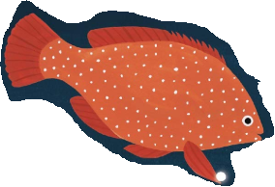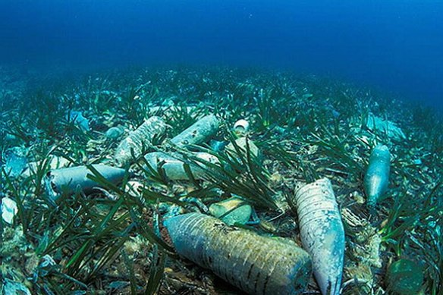

**Which things are precious to you?**

**What would be your personal tresure?**

**treasure**

**Books to Explore, why not borrow one from the library:**

* On the Reef by Judith and Shandley McMurray.
* A Hole in the Bottom of the **Sea** by Jessica Law, Jill McDonald, and The Flannery Brothers.
* **Ocean** Seasons by Ron Hirschi and Kirsten Carlson.
* 10 things I can do to help my world by Melanie Walsh
* Here we are: Notes for living on the planet Earth by Oliver Jeffers
* [First Big Book of the Ocean***by Catherine D. Hughes***](http://amzn.to/2edbl0L)

**Can you name the four seasons?**

**Which season do you like best? Why?**

**season**

**change**

**Things you could do:**

**F**ollow a route on a map or draw your own map of a journey you have taken.

Draw or paint a picture of a coral reef.

Test some different materials in your bath, see which will float and which will sink. Record your results. Explain if the materials changed as they got wet.

Go out on a wintry walk, draw a winter picture, make a weather chart of the weather in the holidays.

**Don’t forget to bring your work in to show us in January.**