Wider Curriculum Areas
Science  Animals Including Humans  The children will study and describe the changes as humans develop to old age.  This will include learning about the changes experienced in puberty.  Physical Education  *Gymnastics will be taught on a Thursday afternoon and Invasion Games (Netball) will be taught on a Tuesday afternoon.  Gymnastics  The children will work to develop flexibility, strength, technique, control and balance.  Netball  Competitive games will be played (modified where appropriate) and basic principles suitable for attacking and defending will be applied.  Religious Education  Judaism  The children will explore the religious symbols of Judaism and Christianity and make comparisons between the religions.  Modern Foreign Languages  French  Children will build on their existing knowledge of the French language and will be able to engage in short conversations about their families.  PSHCE | History/Geography  The children will study the Ancient Greeks and will learn about some of their achievements, as well as their influence on the western world. Children will research areastheir own interests using a variety of different sources.  Art  Children will use a range of techniques, including collage, to create an abstract image of Odysseus.  Computing  Children will use the internet to research areas of interest linked to learning on the Ancient Greeks. They will present their work in their preferred, digital way.  Safe, respectful and responsible use of technology will be taught. The children will learn to recognise acceptable/unacceptable behaviour and to identify a range of ways to report concerns about content and contact.  They will select, use and combine a variety of software (including internet services) on a range of digital devices to design and create a range of programs, systems and content that accomplish given goals, including collecting, analysing, evaluating and presenting data and information.
Ancient Greeks
Autumn Term 1
Year 5 PLOD

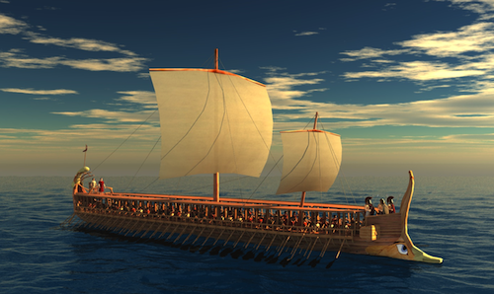
Maths
We will begin the term by securing the children’s knowledge of place value before moving onto using formal methods for addition and subtraction.

Place value
Read, write, order and compare numbers to at least 1000000 and know the value of each digit.
Count forwards or backwards in steps of powers of 10.
Interpret negative numbers in context.
Round any number to 1000000 to the nearest 10, 100, 1000, 10000, and 100000.
Read Roman numerals to 1000 and recognise years written in Roman numerals.
Solve problems involving all of the above.

Addition and Subtraction
Add and subtract numbers mentally with increasingly large numbers.
Add and subtract whole numbers with more than 4 digits using formal written methods.
Use rounding to check answers to calculations and determine, in context of a problem, levels of accuracy.
Solve multi – step problems in context, deciding which operations to use and why.

English
Enhancing our topic work, the children will write letters, in the role of Odysseus, to his wife Penelope, before he leaves for war.
Children will write a diary entry as Odysseus or a member of his’ crew as they try to make their way back to Ithica.
Children will create their own mythical creature which will develop in to character descriptions and writing their own version of Odysseus’ journey (narrative).
The key features of each text type will be discussed and replicated in their own writing. We will look to include exciting vocabulary, advanced punctuation, as well as using and linking paragraphs, to both organise ideas and move narrative forward. Emphasis will also be placed on editing and improving work.

