**What animals live in the Antarctica?**

**Would You Have Brought Your Crew Home Safely?**

Growler

**Where is the Weddell Sea?**

**Who is your favourite Endurance crew member? And why?**

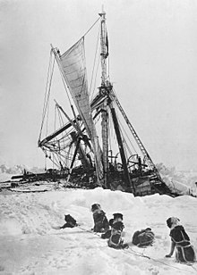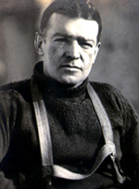

**I thought a desert was sandy!**

Pressure Ridge

**What items would you take to survive in Antarctica?**

Crow’s Nest

**With Endurance We Conquer**

**Who was Ernest Shackleton?**

Blubberck

Hummock

*Books to Read:*

* *Who was Ernest Shackleton? – James Buckley*
* *You Wouldn’t Want to be on Shackleton’s Polar Expedition – Jen Green*
* *Shackleton’s Journey Activity Book – William Grill*
* *100 Facts about Rainforests – Camilla De La Bedoyere*

*Things to Do:*

* *Get a book about Shackleton from the library*
* *Draw a picture of an animal found in Antarctica*
* *Find out the meanings of the* ***Key******Words*** *on this sheet*