Think about keeping healthy, being active in our P.E. sessions and working as a team.

.

Find out about different mini beast and their habitats. Researching how they are different and their similarities.

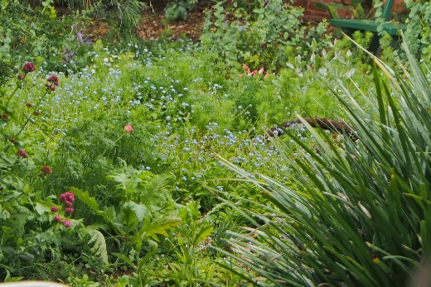

Looking at all kinds of atlases and maps. Finding and learning country names. Making our own maps.

Painting, drawing and making all kinds of models… painting worms and lots of other mini beast and their habitats.

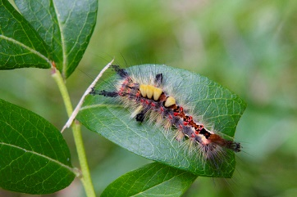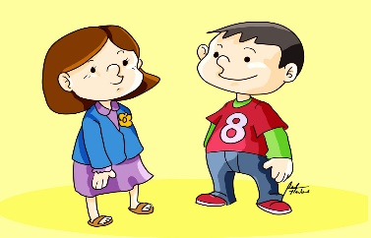

This half term we will …

Continue to do lots of counting, practise, recognising our numbers as well as learning about weight and capacity. We will be doubling and halving numbers to 20.

Continue to develop our speaking and listening skills. Sharing our thoughts and consider the views of others.

Continue to develop our writing skills in lots of ways. Creating labels and captions for our work.

Carry on with the hard work we have started in our garden. Caring for the bulbs and plants we have planted by weeding and watering them.

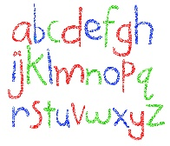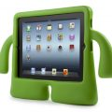

Enjoy lots of information books and stories, especially Yucky Worms.

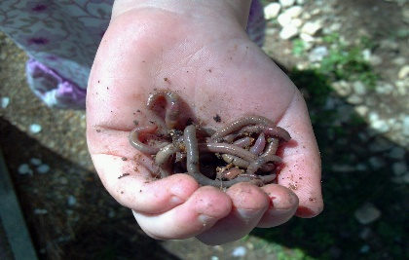

Use technology such as the ipad or photocopier to help us record and share our learning.