**Why did WWII start?**

**What items were rationed during WWII?**

Holocaust

**Would you have entered Britain into WWII?**

**Which were the main countries involved in the war?**

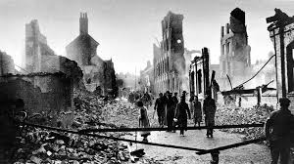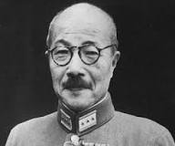

*Books to Read:*

* *My Secret War Diary - Flossie Albright*
* *Goodnight Mister Tom – Michelle Magorian*
* *The Diary of Anne Frank*
* *War Boy - Michael Foreman*

*Things to Do:*

* *Write a fact-file about one of the world leaders during WWII*
* *Draw a picture of a WWII vehicle*
* *Find out the meanings of the* ***Key******Words*** *on this sheet*

D-Day

**Evacuation – how would you have felt?**

**What was the land army? Who joined the land army?**

**Who was Hideki Tojo?**

**There is nothing to fear but fear itself.**

Propaganda

Allies

Treaty