Who were The Tudors?

**Bosworth**

**Was Henry VIII a rose or a thorn?**

Why was the battle of Bosworth so important?

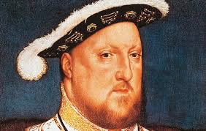

**Banquet**

Can you create a timeline of British Kings and Queens before and after King Henry?

What is the meaning of the Tudor Rose?

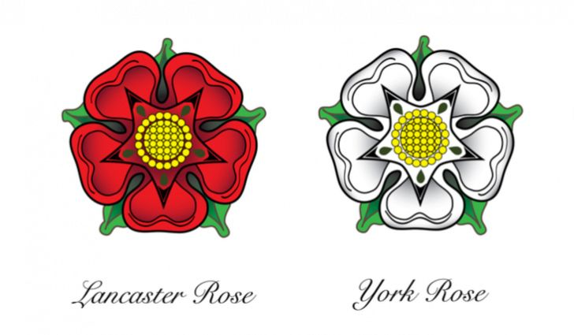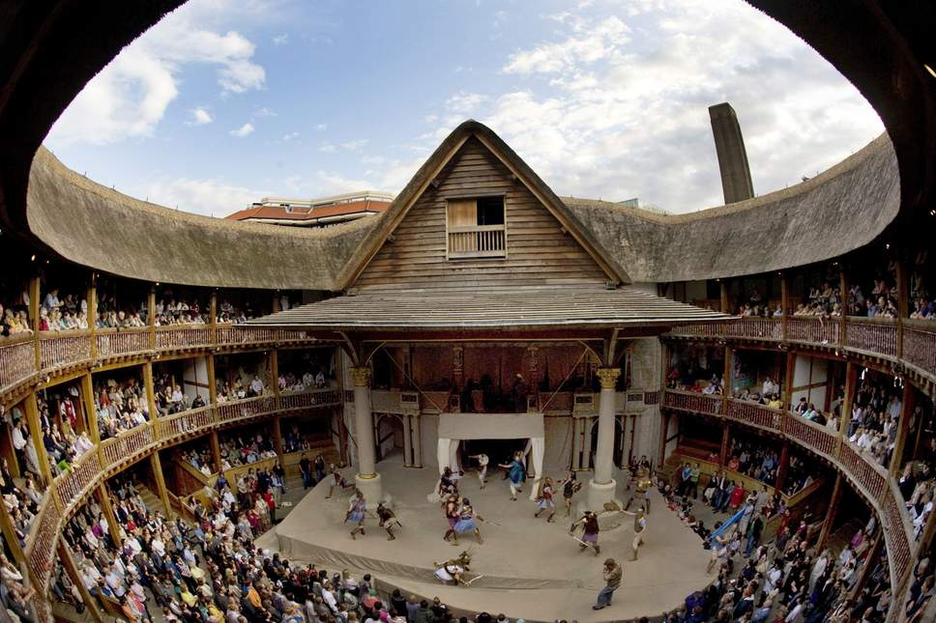

**Shakespeare**

**Monarch**

Can you find out the titles of some of the plays written by William Shakespeare?

Can you find out what King Henry VIII liked to do in his leisure time?

**War of the Roses**

**Hampton Court Palace**

**Things you could do:**

Visit the library and do some research about The Tudors

Take a trip to Fountains Abbey

Try a new food and write a short review about your experience

**Books and Websites to Explore:**

Terrible Tudors – Teery Deary

The secret diary of Thomas Snoop – Philip Ardagh

The Tudors – Tim Pipe

<http://www.primaryhomeworkhelp.co.uk/Tudors.html>

<https://www.natgeokids.com/uk/discover/history/general-history/tudor-facts/>