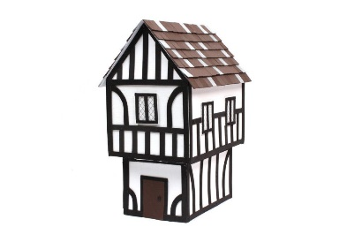

Were Tudor boys treated differently to Tudor girls?

**Architecture**

What materials were used to build Tudor houses?

**Was Henry VIII a rose or a thorn?**

**(PART 2)**

**Childhood**

What was the cause of the Plague?

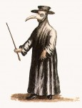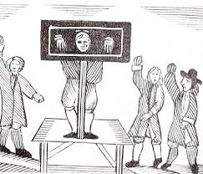

**Entertainment**

Did children go to school?

What were the consequences of committing a crime during Tudor times?

**Plague**

**Education**

What did Tudors do for entertainment?

**Punishment**

**Things you could do:**

Visit the library and find the answers to these questions

Find the name of the nursery rhyme that was written about the plague.

Make a Tudor style house

**Books and Websites to Explore:**

Terrible Tudors – Terry Deary

The secret diary of Thomas Snoop – Philip Ardagh

The Tudors – Tim Pipe

<http://www.primaryhomeworkhelp.co.uk/Tudors.html>

<https://www.natgeokids.com/uk/discover/history/general-history/tudor-facts/>