**Can you remember the names of all 5 continents?**

**Algorithm**

**Where in the world?**

**Continent**

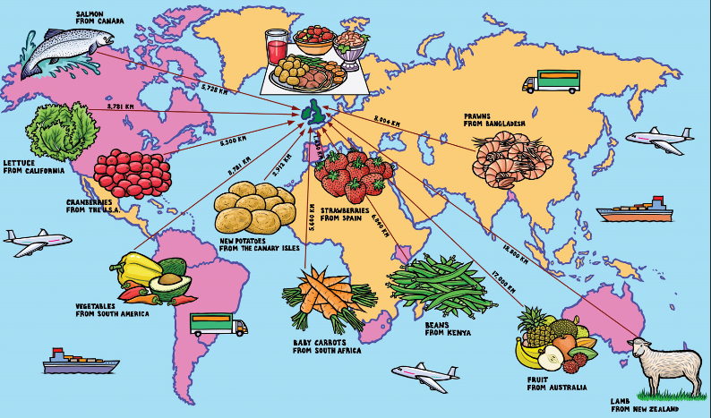

**What is an algorithm?**

**(An extra tricky one!)**

**Can you eat the fruit of all plants?**

**Do all plants grow fruit?**

**Which is your favourite? ?fruit? How does it grow?**

**Which foods are good for us?**

**Where does our food come from?**

**Why is the food we eat important?**

**Books to Explore:**

* The many versions of ‘Little Red Riding Hood’ and ‘The Three Little Pigs’
* ‘Yummy’ by Lucy Cousins
* ‘A Necklace of Raindrops’ by Joan Aitkin
* ‘I am so Strong’ by Mario Ramos
* Aesop’s Fables
* ‘Beware of the Storybook Wolves’ by Lauren Child

**Things you could do:**

Why not look closely at the labels on fruit and vegetables in the supermarket. How many different countries can you find that our food comes from? Bring in the label for our food map.

Try a new fruit of vegetables that you have never had before, think of some good words to describe how it tastes to us.

Why not visit the library and find a story from another country. Bring it in to read in school.

**What is a traditional tale?**

**Can you tell us a story?**

**Traditional Tale**

**Fruit**

**Nutrition**