**Can you find or write a story showing the wolf as a good character?**

**Are they all bad?**

**Who’s afraid of the big bad wolf?**

**Habitat**

**Can you create a shoe box version of a natural habitat for a wolf?**

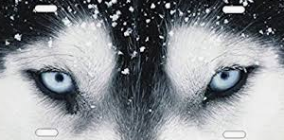

**How many?**

**How many types of wolves can you name? Write a sentence about each. one.**

**Why are wolves amazing?**

**Things you could do**

**Go to the library**

**Research wolves on the internet, as long as you have an adult’s permission.**

**Pack**

**Can you write three amazing facts about wolves?**

**What is a wolf pack?**

**Books to Explore:**

**Good little wolf by Nadia Shireen**

**Little Red by Bethan Woollvin**

**Various versions of Little Red Riding Hood.**

**Three little wolves and the Big Bad Pig by Eugene Trivizas and Helen Oxenbury**

**Legendary**

**Fact file**