Year One
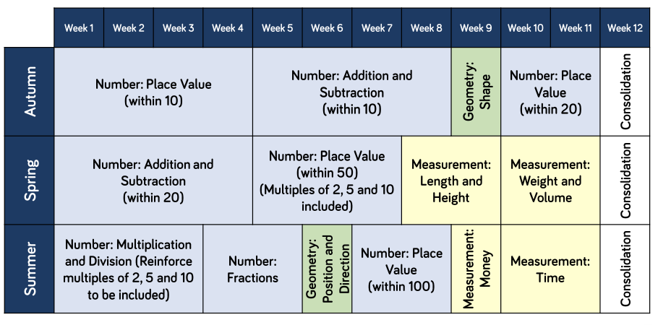
Teachers will use this long term plan as a guide alongside their professional judgements to deliver a mathematical curriculum to benefit the children that they are currently teaching.

