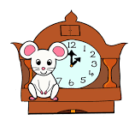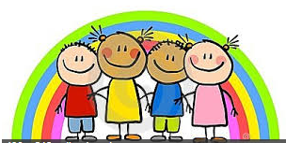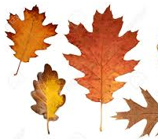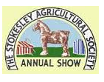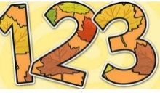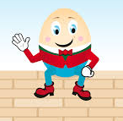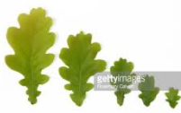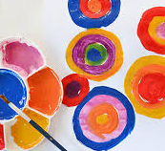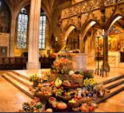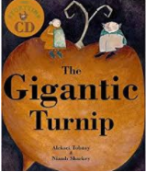

Make new friends. Spend time getting to know our new class mates, finding out about what makes us the same and different.

This half term we will …

Investigate colour and learn more about what happens when we mix colours. Talk about favourite colours.

Enjoy dancing and get moving to the beat! Make up our own rhythms and dance to them.

Learn lots of rhymes, sing favourite ones that we already know and make up new ones by changing the rhyme.

Enjoy lots of books and stories, especially Owl Babies and The Gigantic Turnip

Find out about Harvest. We will harvest the vegetables in our garden and plant some bulbs. We will hopefully be cooking soup

Find out more about the seasons by watching for signs of Autumn and getting out and about collecting Autumn treasures .

Do lots of counting, practise recognising our numbers as well as learning about size and shape.

Enjoy talking about the Stokesley show and fair, finding out a bit more about the place that lots of us live.

