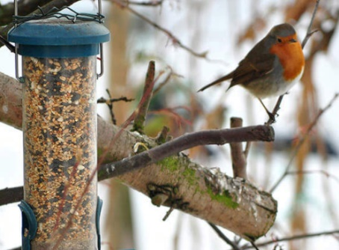

Learning about sharks, finding out about the places where sharks live. Asking questions and finding out the facts to answers the questions.

In P.E. we will be working on our coordination and working as a team in games.

Painting, drawing and making models of under the sea animals and habitats.

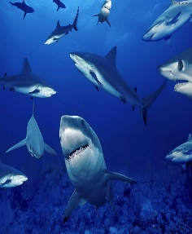

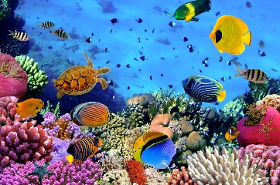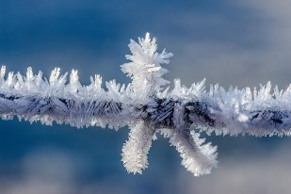

Find out more about the seasons by observing winter. Investigating ice and snow and looking after the birds in our garden, making winter bird food.

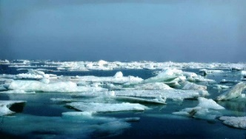

This half term we will …

Do lots of counting, practise recognising our numbers as well as learning about size and shape. We will also be learning about finding totals, adding and taking away.

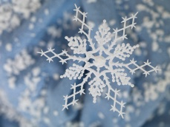

Developing our writing skills in lots of ways. Creating labels and captions for our work and carrying on with our phonics.

Use technology such as the ipad or photocopier to help us record and share our learning.

Learn more about feelings, thinking about what we like to do with our friends, also how we can cheer our friends up when they are feeling sad.

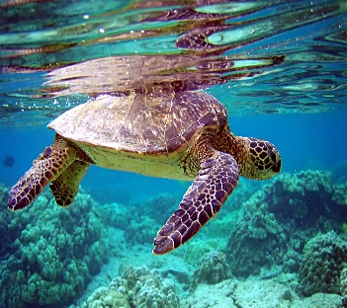

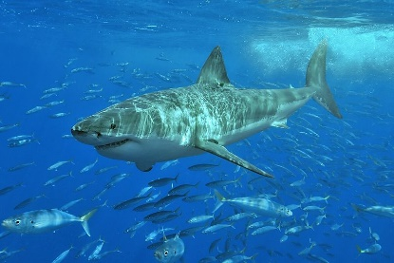

Enjoy lots of fiction and non-fiction books, relating to animals and creatures you will find under the sea.

