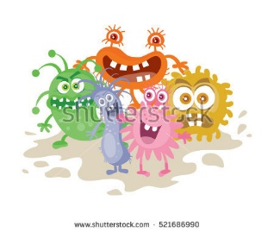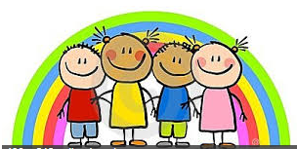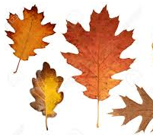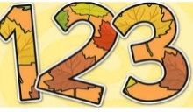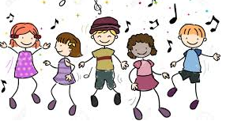

We will be thinking about taking turns and being aware of how our actions may make others feel.

This half term we will …

We will be creating friendly monster puppets and paintings.

Enjoy dancing and get moving to the beat using different body parts.

We will learn more about festivals, bonfire night, advent and Christmas.

Watch for the sign for the end of Autumn. Getting busy in our garden planting bulbs ready for spring.

Enjoy improving our fine motor skills by doing lots of cutting, threading and weaving activities.

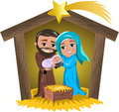



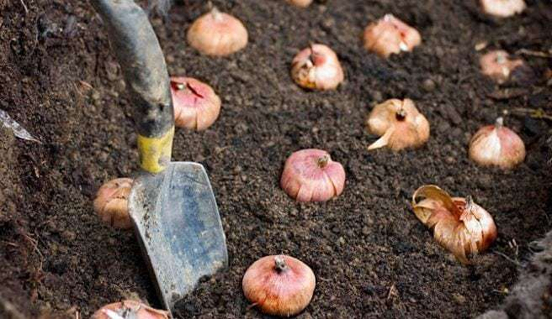

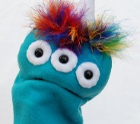

We will be singing lots of number rhymes and songs. We will be grouping objects and counting them.

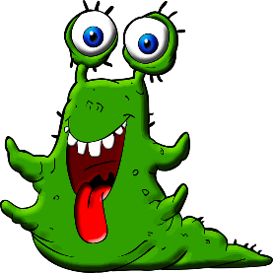

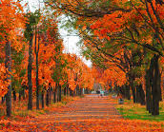

We will do lots of phonic activities and will learn lots of rhyming. We will use technology such as iPads or photocopier to record our learning.

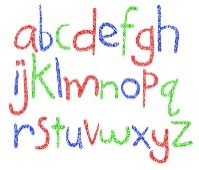

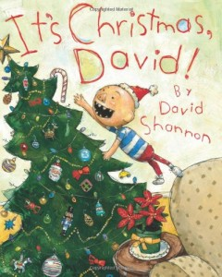

Enjoy lots of books and stories, especially Bedtime for Monsters by Ed Vere and books linked to Christmas.

