

Painting, drawing and making all kinds of models… especially vehicles, diggers, buses and emergency vehicles.

Find out more about the seasons by looking out for the first signs of spring, getting the garden ready for planting and continuing to look after the bulbs that we planted.

Thinking about keeping healthy, being active in our PE sessions, developing skills like rolling, jumping, hopping, skipping and balancing.

Learning about vehicles. Asking questions and finding out the answers.

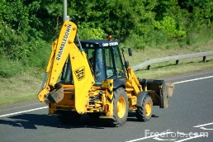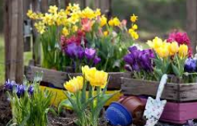

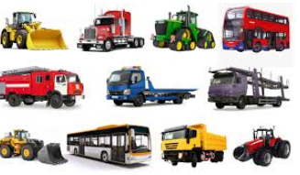

This half term we will …

Do lots of counting, practise recognising our numbers as well as learning about weight and capacity. We will also be learning about finding totals, adding and taking away.

Developing our writing skills in lots of ways. Creating labels and captions for our work.

Finding out about Shrove Tuesday and Easter. Developing our understanding that different people celebrate in different ways at different times.

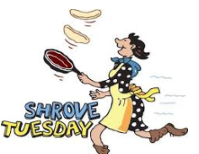

Learn more about feelings, thinking about feeling scared and how we can cope with this big feeling. Learning more about how to be a good friend.

Enjoy lots of books and stories, especially Naughty Bus by Jan and Jerry Oke.

Use technology such as the ipad or photocopier to help us record and share our learning.

